Close Contacts Notification Script for School Nurses

The purpose of this script is to support school nurses with follow up calls to inform parents/guardians that their child was a close contact of a confirmed positive COVID-19 case. Gloucester County Department of Health and Human Services appreciates your support in calling impacted individuals. Your work helps expand our capacity and ensures we can reach every individual to help reduce and eliminate the spread of COVID-19.

Instructions:

- Please say the following to the parent/guardian:

This is [YOUR NAME] calling you on behalf of [SCHOOL]. You are being called because your child has been identified as a close contact to a person with a confirmed novel coronavirus infection.

- Remind the parent/guardian that there is no immediate cause for alarm, as there are fewer cases of COVID-19 among children, with most of them being asymptomatic, mild, or moderate. Complications appear to be less common in children. Tell the parent/guardian that you are asking a few questions today and providing information that will help reduce the spread.

- Ask: Does your child or anyone in your family currently have any symptoms of COVID-19?

For reference, symptoms include:
  - dry cough
  - fever
  - shortness of breath
  - chills
  - sore throat
  - fatigue
  - muscle/body aches
  - headache
  - congestion/runny nose
  - nausea/vomiting
  - diarrhea
  - new loss of taste/smell

- Isolation vs. Quarantine
  - Isolation separates sick people with a contagious disease from people who are not sick.
  - Quarantine separates and restricts the movement of people who were exposed to a contagious disease to see if they become sick.
- Follow step 4a or 4b depending on symptom status, and refer to the New Jersey Department of Health’s Timeframe for Self-Isolation/Quarantine based on Testing Result chart below as needed:

  - IF CHILD/ANYONE IN HOUSEHOLD HAS SYMPTOMS:
    - Ask: If have any symptoms, have they been tested for COVID-19?
      - If yes:
        - If tested negative, say: Since your child has been identified as the contact of a confirmed novel COVID 19 case, they will need to be at home quarantining until [14 DAYS AFTER CONFIRMED CASE’S LAST DAY IN SCHOOL]. Even though the test was negative, the time in which COVID-19 can appear after exposure is 14 days. Currently, it is only recommended that the close contact of a case quarantines, meaning your whole household does not need to quarantine.

        - If tested positive, ask if they have started isolating, and if so, what that start date was. Tell them the positive case has to isolate at least ten days since symptoms began, until fever free without medication for 24 hours, and until symptoms have resolved.

          - If the child is not the positive case in the home, say: Since your child has been identified as the contact of a confirmed novel COVID 19 case, they will need to be at home quarantining until [14 DAYS AFTER CONFIRMED CASE’S LAST DAY IN SCHOOL] AND 14 days after the self-isolation ends for the positive case in home, whichever one comes later.

      - If no, say: We recommend they get tested and follow up with a healthcare provider. Since your child has been identified as the contact of a confirmed novel COVID 19 case, they will need to be at home quarantining until [14 DAYS AFTER CONFIRMED CASES’ LAST DAY IN SCHOOL]. Currently, it is only recommended that the close contact of a case quarantines, meaning your whole household does not need to quarantine.

  - IF NO SYMPTOMS AMONG CHILD OR ANYONE IN HOUSEHOLD:
    - Say: Since your child has been identified as a contact to a confirmed novel coronavirus case but does not have symptoms, they are on home quarantine until [14 DAYS AFTER CONFIRMED CASES’ LAST DAY IN SCHOOL]. Currently, it is only recommended that the close contact of a
    - case quarantines, meaning your whole household does not need to quarantine.

- Assess whether the child is low or high risk by asking: Is your child immunocompromised or have any underlying medical conditions?
  - If yes, recommend letting their healthcare provider know of the exposure.

- Inform parent/guardian of cautionary measures by saying:

In order to prevent the potential spread of the virus, postpone all travel, avoid crowded places, and limit activities in public including social gatherings. If someone in your household needs to see a healthcare provider, call your provider ahead of time and let them know of the exposure. Reschedule any non-emergency medical or dental appointments. Wear a mask, wash hands often, social distance, and sanitize frequently touched services such as door knobs.

- Inform parent/guardian of remote learning opportunities and procedures that are specific to your school.

- Ask the parent/guardian if they need any additional help with food or medical needs in order for their child to self-quarantine for the next 14 days

  - Provide referrals as needed – to social services and/or local food pantries

- Ask the parent/guardian if they have any questions. Inform them to go to the CDC or NJ Department of Health websites for more information:

  - https://www.cdc.gov/coronavirus/2019-ncov/
  - https://covid19.nj.gov/

- Thank them for their support with this requirement in order to keep the school community safe.

- After the call is over, complete documentation and any follow up needed (ex. If child tested positive for COVID 19)

Please note that healthcare personnel and essential employees may follow different guidance from CDC/NJDOH. Please refer to the following resources for further explanation:

Guidance for COVID-19 Diagnosed and/or Exposed Healthcare Personnel dated 8/11/20

https://www.nj.gov/health/cd/topics/covid2019_healthcare.shtml

https://www.nj.gov/health/cd/documents/topics/NCOV/Healthcare%20Personnel%20(HCP)%20Exposure%20to%20Confirmed%20COVID-19%20Case%20Risk%20Algorithm.pdf

https://www.cdc.gov/coronavirus/2019-ncov/community/critical-workers/implementing-safety-practices.html?CDC_AA_refVal=https%3A%2F%2Fwww.cdc.gov%2Fcoronavirus%2F2019-ncov%2Fcommunity%2Fcritical-workers%2Fessential-critical-workers.html

For Reference: New Jersey Department of Health’s Timeframe for Self-Isolation/Quarantine based on Testing Result

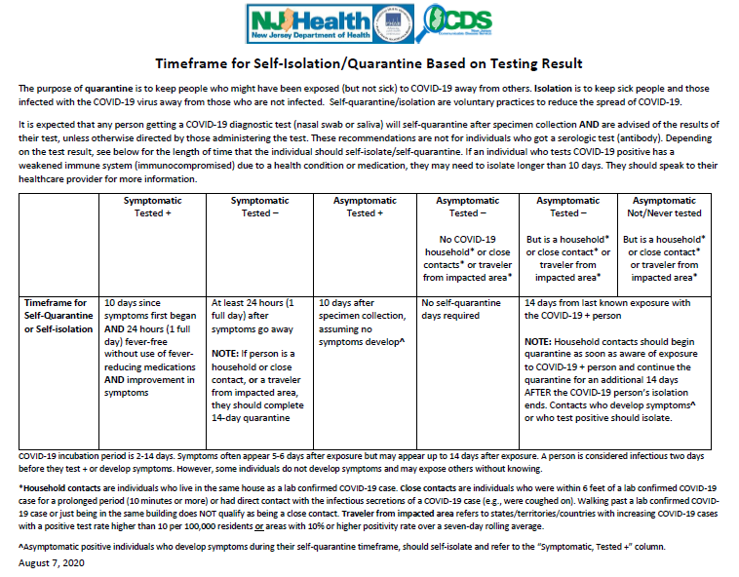
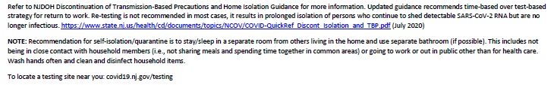

Tips from Call Center Staff to have Successful Calls

- Take notes: Document any information that may not be otherwise captured. This will help you reference back to it if necessary. This will also help you become an active listener.

  - Make sure you shred this paperwork as it may contain protected health information

- Try to Sound Confident and Relaxed: It is not easy to call with this information, and may feel uncomfortable at times. The more confident and relaxed you sound, the more the
Parent/guardian will mirror your energy.

- It’s Ok Not to Know Something: If you do not have the answer, give the patient resources of where they can find out this information, such as the CDC’s website, their own healthcare provider, or the NJ COVID Hotline at 1-800-962-1253.

- Address the parent/guardian by name: Use the respectful Mr./Mrs./Ms. [Last Name], or their first name if they ask you to call them by it. This will help the call feel more personal.

- Be patient: Allow the parent/guardian the time needed to reflect on the information and questions asked.

- Take the time you need in between each call: Be sure to take care of yourself- get food,
stay hydrated, go to the bathroom. These calls can be stressful and emotional, so your
self-care is important so you don’t burn out.

Thank you!!

